Big mountain ski resort, The company have an insufficient pricing strategy, after a cost of $1,540,000 the company is looking to have a data-driven pricing by evaluating their facilities and amenities and that will either justify a higher ticket price or cutting costs by finding what facilities or amenities provide the the least value to their customers .

We started with a data set of 330 different competitor ski resorts across the states (330 rows and 27 columns) "Big Mountain Resort," was present in the dataset, we started cleaning the data by finding duplicates values and outliers especially the weekend prices and the normal day price of tickets, then we looked at the distribution of the data for each feature/column and found a few skewed ones like the ‘SkiableTerrain_ac’ caused by an incorrect outlier number for Silverton Mountain in Colorado, Also we dropped ‘fastEight’ as it was of no values, we also dropped rows with no prices about 14% of the rows have no price data

After that we pulled a different data set for the each state from Wikipedia containing the ‘state’ ‘state_population ‘state_area_sq_miles’ and cleaned that data to combined both datasets into one using ‘state’ as the common factor between the two data sets
We also explored the pricing data and decided to drop the ‘AdultWeekday’ column as its similar to the ‘AdultWeekend’ but had more missing values and had to choose one of the two
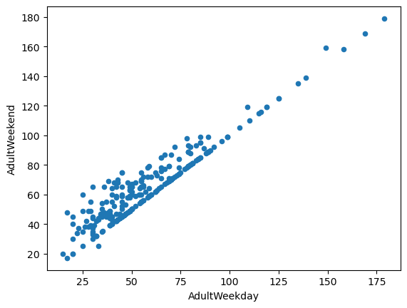
lastly, we have 277 rows and 25 columns after cleaning with no resort missing more than 20% of its information
At this stage, the project is in the data cleaning and wrangling phase. Some missing values remain; however, the dataset is now sufficiently clean for exploratory data analysis.
The target variable for this project is ticket price, which will be predicted using resort characteristics and state-level attributes.
After exploring the top five in each feature (total state area, total state population, resorts per state, total skiable area, total night skiing area, total days open) and also exploring and visualizing resort density analysis by getting the ration of (resorts per 100kcapita) and (resorts per 100ksq mile)
we found various trends. Some states are higher in some but not in others. Some features will also be more correlated with one another than others, so we decided to do a principle component analysis PCA, we scaled the data and then fit the PCA transformation then applied the transformation to the data to create the derived features, after we plotted the first two PCA component (PC1,PC2) to the states names in a scatter plot ('New Hampshire' and 'Vermont') were both outliers, both states have particularly large values of resorts_per_100ksq_mile in absolute terms, and Vermont also has a notably large value for resorts_per_100kcapita
We decided to treat all states equally and work towards building a pricing model that considers all states together without treating any one particularly special we haven’t seen any clear grouping yet but we captured potentially relevant state data in features most likely to be relevant to the business case
We go back to the ski data after the PCA and find ratios for (resort_skiable_area_ac_state_ratio, resort_days_open_state_ratio, resort_terrain_park_state_ratio, resort_night_skiing_state_ratio) and created a heatmap for all the features except the ones we replaced by ratios ('state_total_skiable_area_ac','state_total_days_open','state_total_terrain_parks','state_total_nightskiing_ac')
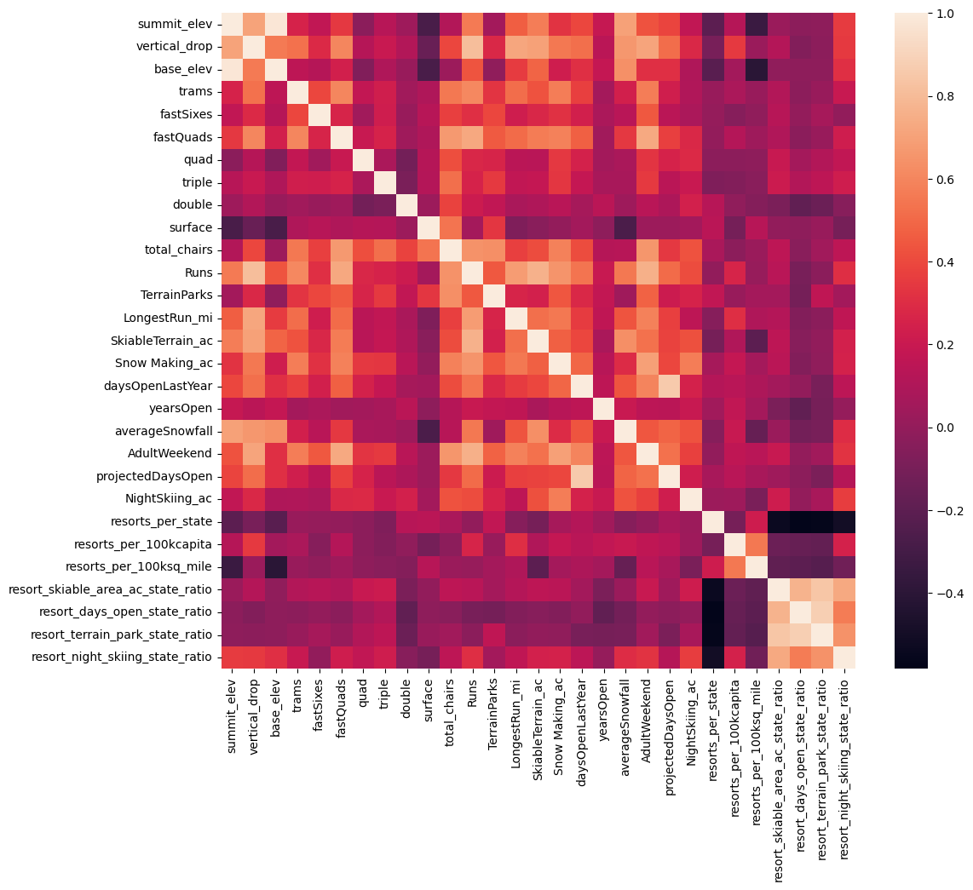

An interesting observation in this heatmap is that it seems that when resorts are more densely located with population, more night skiing is provided.
Turning our attention to the target feature, AdultWeekend ticket price, we see quite a few reasonable correlations. fastQuads stands out, along with Runs and Snow Making_ac. The last one is interesting. Visitors would seem to value more guaranteed snow, which would cost in terms of snow making equipment, which would drive prices and costs up. Of the new features, resort_night_skiing_state_ratio seems the most correlated with ticket price. If this is true, then perhaps seizing a greater share of night skiing capacity is positive for the price a resort can charge.
As well as Runs, total_chairs is quite well correlated with ticket price. This is plausible; the more runs you have, the more chairs you'd need to ferry people to them! Interestingly, they may count for more than the total skiable terrain area. For sure, the total skiable terrain area is not as useful as the area with snow making. People seem to put more value in guaranteed snow cover rather than more variable terrain area.
The vertical drop seems to be a selling point that raises ticket prices as well.
We also created a series of scatterplots to really dive into how ticket price varies with other numeric features. In the scatterplots we see what some of the high correlations were clearly picking up on. There's a strong positive correlation with vertical_drop. fastQuads seems very useful. Runs and total_chairs appear quite similar and also useful. resorts_per_100kcapita shows something interesting that you don't see from just a headline correlation figure. When the value is low, there is quite a variability in ticket price, although it's capable of going quite high. Ticket price may drop a little before then climbing upwards as the number of resorts per capita increases. Ticket price could climb with the number of resorts serving a population because it indicates a popular area for skiing with plenty of demand. The lower ticket price when fewer resorts serve a population may similarly be because it's a less popular state for skiing. The high price for some resorts when resorts are rare (relative to the population size) may indicate areas where a small number of resorts can benefit from a monopoly effect. Later we view the ratio of chairs to runs ('total_chairs_runs_ratio', 'total_chairs_skiable_ratio', fastQuads_runs_ratio', 'fastQuads_skiable_ratio') At first these relationships are quite counterintuitive. It seems that the more chairs a resort has to move people around, relative to the number of runs, ticket price rapidly plummets and stays low. What we may be seeing here is an exclusive vs. mass market resort effect; if you don't have so many chairs, you can charge more for your tickets, although with fewer chairs you're inevitably going to be able to serve fewer visitors. Your price per visitor is high but your number of visitors may be low.
It also appears that having no fast quads may limit the ticket price, but if your resort covers a wide area then getting a small number of fast quads may be beneficial to ticket price.
Reviewing the metrics, the mean absolute error was 19, this essentially tells us that, on average, we might expect to be off by around $19 if we guessed ticket price based on the average of known values.
To train our model we decided to do a 70/30 test split where 70% is for training our model and 30% is for testing it
We started with an initial model to predict missing values first and tested both the mean and median to be used to fill in the missing values, the median gave a slightly more accurate data and that’s what we used in our model to fill in the missing data.
Later we created two pipelines, one using linear regression and another using random forest, the model using random forest gave a more accurate pricing prediction
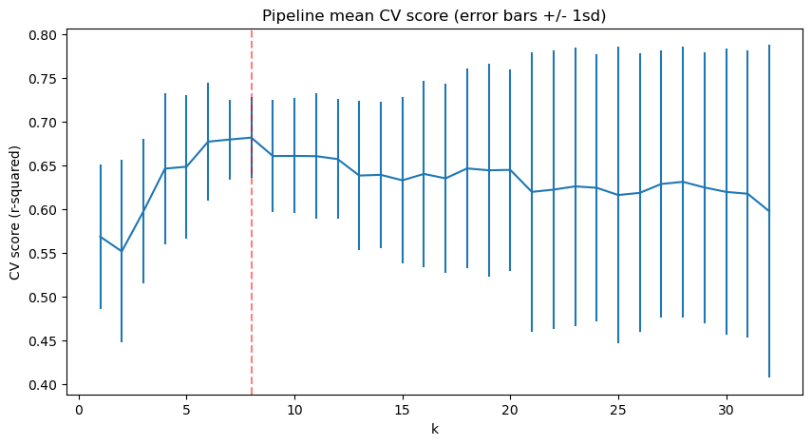
We found that using eight features was the best way to train our model more columns created more noise and wasn’t beneficial, the top eight features that affected pricing were as follows (with number of coefficient)
vertical_drop 10.767857
Snow Making_ac 6.290074
total_chairs 5.794156
fastQuads 5.745626
Runs 5.370555
LongestRun_mi 0.181814
trams -4.142024
SkiableTerrain_ac -5.249780
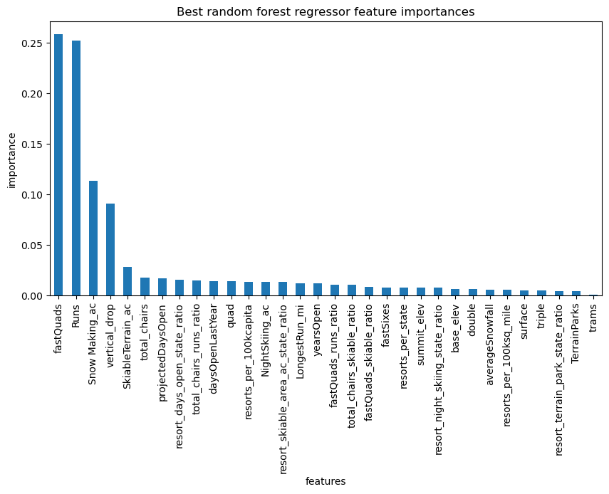
Also the best random forest regressor feature by importance was as shown in the graph above
With the top four features ( fastQuads Runs Snow Making_ac vertical_drop)

Big Mountain currently charge $81 per ticket, our model suggests a price of $95.87, given that big mountain was one of the leading resorts in the top 7 out of 8 features that had the strongest correlation with price only because of no trams! But all other features were above average! Features like vertical drop, snow making machines, total chairs, fast quads, runs, longest runs, and skiable terrain.
If Big Mountain decides to increase their price up to95 per ticket from 81 the revenue will increase by $26,22,500 per season with a projected visitors of 350,000 and each buying 5 tickets or if they decid to increased it up to $90 the revenue would be at 15,750,000.
Either way the $1,540,000 cost for the extra chair would be covered within one season!
As for the four different scenarios the company shortlisted, our analysis shows the following :
Scenario 1 - The model says closing one run makes no difference. Closing 2 and 3 successively reduces support for ticket price and so revenue. If Big Mountain closes down 3 runs, it seems they may as well close down 4 or 5 as there's no further loss in ticket price. Increasing the closures down to 6 or more leads to a large drop.
Scenario 2 - This scenario increases support for ticket price by 1.99 Over the season, this could be expected to amount to $3,474,638
Scenario 3 - Makes no difference than scenario 2 in outcome!
Scenario 4 - No difference whatsoever
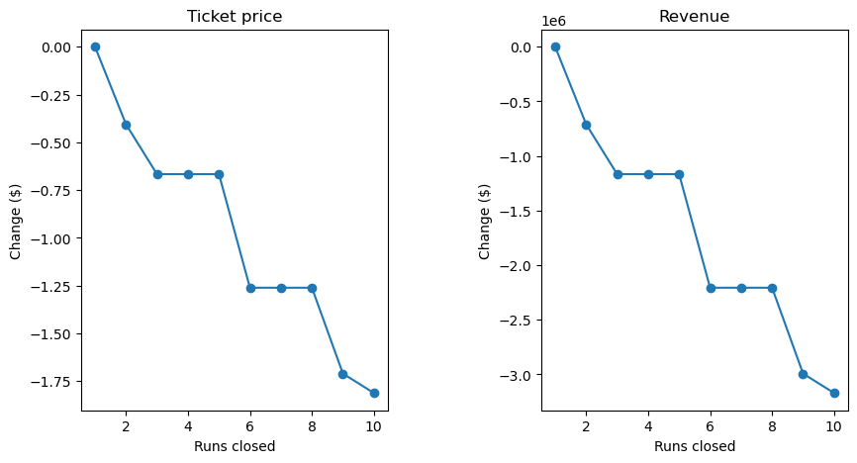
Our recommendation would be to close down only one run as this will have no effect on the price! And going with scenario # 2 to maximize profit and lower cost.
As for the ticket price we recommend that the price increase happen gradually in the next three seasons until it reaches $95.87 and that is if they did not go with any scenario of the four! If they did go with scenario #2 ticket price would increase an extra 1.99 to cover expenses

The current price was just a guesstimate of upscaling the average price, and Montana big mountain was the highest priced resort from our data in the state of Montana, raising the price to $95.87 is a big jump but also big mountain scores above average in almost all of the top 8 features that has a strong correlation with ticket price not only state wide but for the whole country across hundreds of different ski resorts big mountain came out in one of the tops! Maybe raising the price in a sequence of the next three seasons or so might not create such a big ticket shock to loyal customers!

Look at where Big Mountain sits overall with top features amongst all resorts:
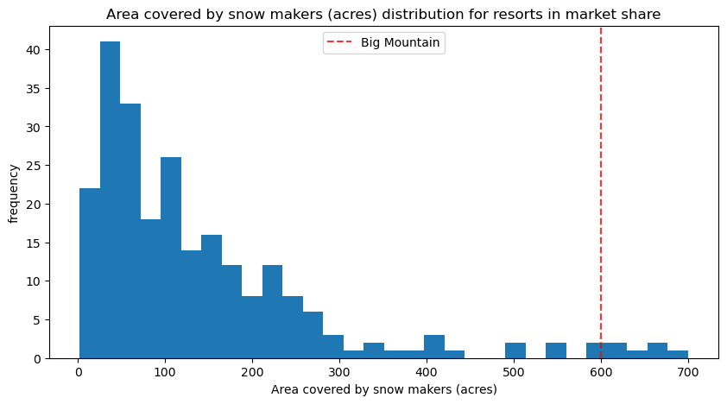
Big Mountain is very high up the league table of snow making area.

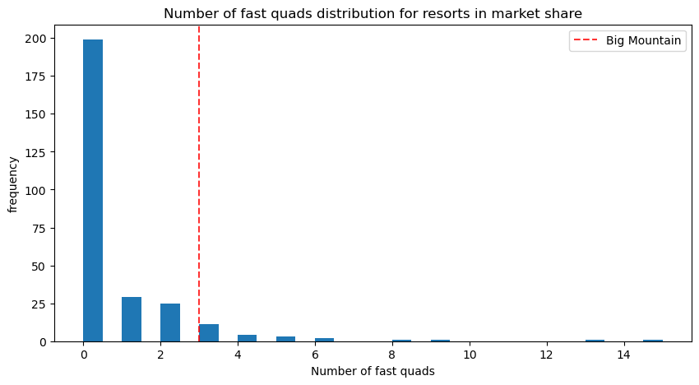
Most resorts have no fast quads. Big Mountain has 3, which puts it high up that league table. There are some values much higher, but they are rare.

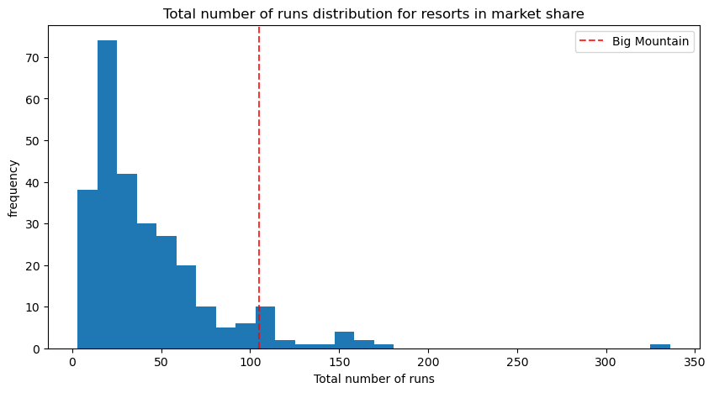
Big Mountain compares well for the number of runs. There are some resorts with more, but not many.
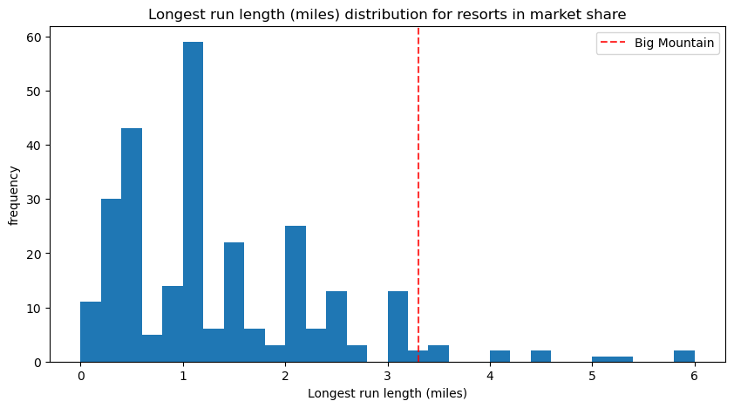
Big Mountain has one of the longest runs. Although it is just over half the length of the longest, the longer ones are rare.
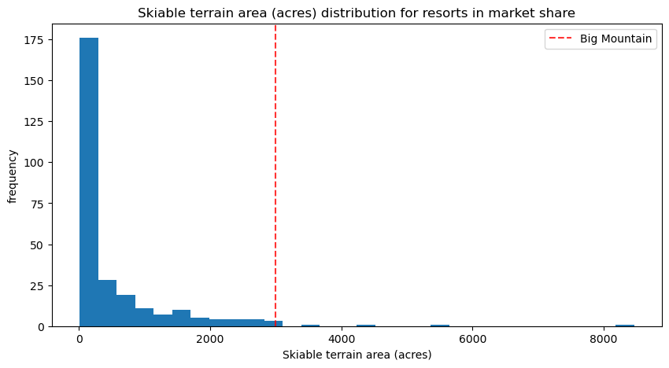
Big Mountain is amongst the resorts with the largest amount of skiable terrain.

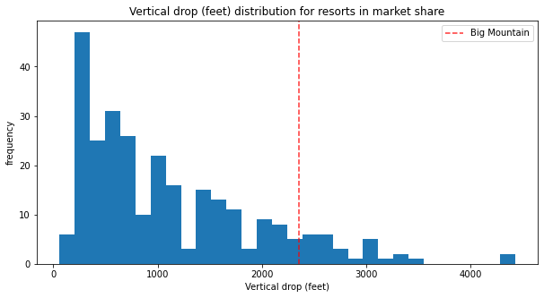
Big Mountain is doing well for vertical drop, but there are still quite a few resorts with a greater drop.

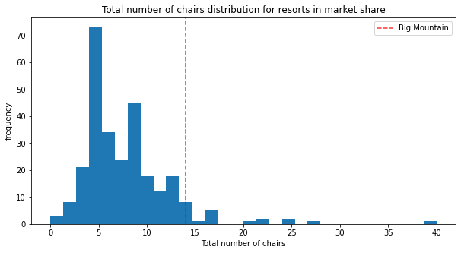
Big Mountain has amongst the highest number of total chairs, resorts with more appear to be outliers.

